

Changing Lives Through learning

**Student ID: 3157051**

**Student Name: Gagandeep Kaur**

***This section is to be completed by the assessment designer***

|  |  |  |  |
| --- | --- | --- | --- |
| **Qualification** | | **New Zealand Diploma in Software development Level 6** | |
| **Course(s) code and Title** | | **MVC major project** | |
| **Course Level** | | **L6,** | |
| **Assessment Title and Version** | | **MVC major project and Design** | |
| **Assessment Type** | | **Report** | |
| **Intake** | | **September 2020** | |
| **Campus** | | **East Tamaki, Auckland** | |
|  |  |  |  |
|  |  |  |  |

Table of Contents

Project Scope 3

Purpose 3

Goal 3

Features 3

Target Audience 3

Page content details 4

Home page ---------------------------------------------------------------------------------------------4

Contents & elements of home page 4

Companies page 5

Contents & elements of companies page 5

Receiver’s page  6

Contents & Elements of receiver page 6

Sender page 6

Contents & Elements of sender page 7

Parcel page 7

Contents &Elements of Parcel page 8

Tracking page----------------------------------------------------------------------------------------8

Contents & Elements of Tracking page 9

Registration page------------------------------------------------------------------------------------9

Login page 10

Brand name 10

Task details 10

System Configuration 10

User Access Levels 10

Project Scope

Purpose

The main purpose of implementing this website is to make it famous among people. It is very easy to use. People can send and receive parcel from worldwide through Worldwide parcel which has different courier companies like Fed ex, DHL, Expert courier and many more. The main purpose of it is to make people’s life easy means they can enjoy anything around the world by getting that stuff by parcel by sitting at home.

Goal

To earn trust: The goal of this website is to earn customers trust regarding Worldwide parcel, so that it becomes number one company in their eye, and they give first preference to my company.

Explore business: Online business has become very common everywhere, hence this website will help to explore my business and help to increase the number of customers.

Features

* Easily accessible: This website is responsive website means anyone can easily access it on different sizes electronic device like mobile phone and laptop.
* Login page: With the help of Login page customers who have already created account can login easily by filling their username and password. Also, if they forgot password, they could easily get it changed by clicking on reset password option given over there.
* Register page: Register page will help to new user to register themselves so that they can easily login to the website for the next time. On register page they have to set username and password by giving their email id where they will get confirmation and can become member.
* This website also has Add, delete, and edit page to check the details of parcel company, receiver, sender and tracking number also.

Target audience

The target audience of this website is to let the people know about this Worldwide parcel company and make it famous among them and to earn their trust.

Page Content Details

Home

Purpose of the Home Page

The main motive of this page is to provide basic information about the Worldwide parcel company and this page will help customers to get to know basic of this website.

Contents and Elements of Home Page

On this page an image is placed in the center of the page and above it there is navigation bar including home page, companies, senders, receivers, tracking number, along with it there is registration and login page also.

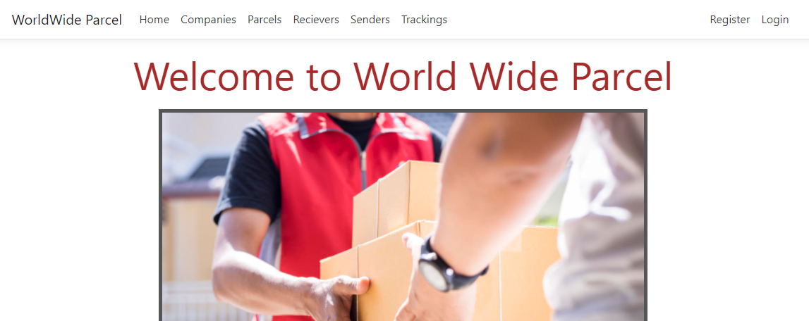

Companies

Purpose of the company’s page

The main purpose of this page is to let the people know about the various companies come under Worldwide parcel.

Contents and Elements of Services page

On this page a large table open with the information of company name, address, website, email address and mobile number. This information will help customers to get to know about various companies and can choose according to their desire. After this there is an image on the whole page.

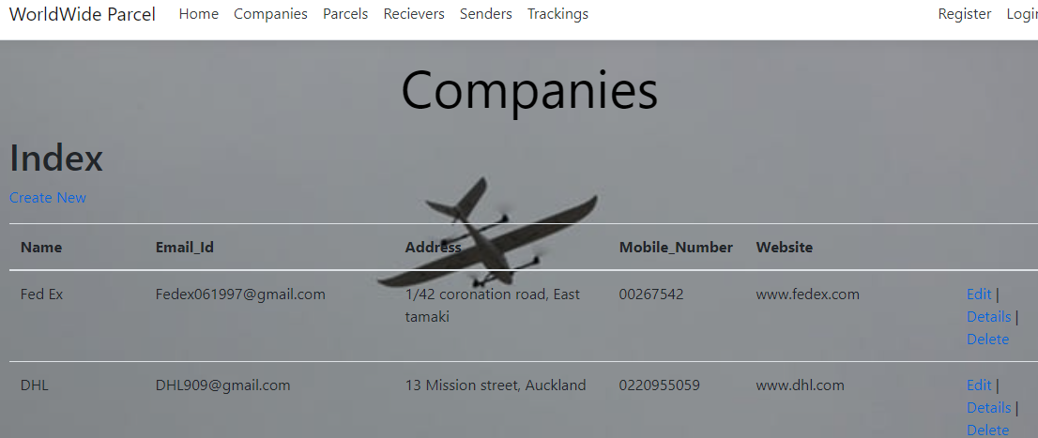

Receiver

# Purpose of the Receiver page

This page will help us to know about the information of that person who goanna receives the parcel sent by his or her known.

Contents and Elements of Receiver page

On this webpage there is a background image with having text on it. The table provides the information about the name, mobile number, and some other information of the receiver.

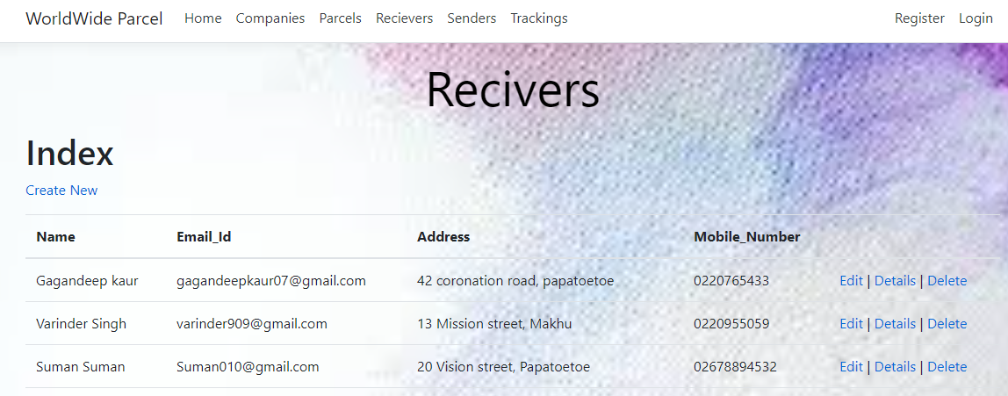

Senders

Purpose of the sender’s page

The purpose of the page is to provide latest information to the clients about the Senders.

Contents and Elements of sender’s page

This page is decorated with a background image and as the other pages this page also give information about sender’s name, address, mobile number and other.

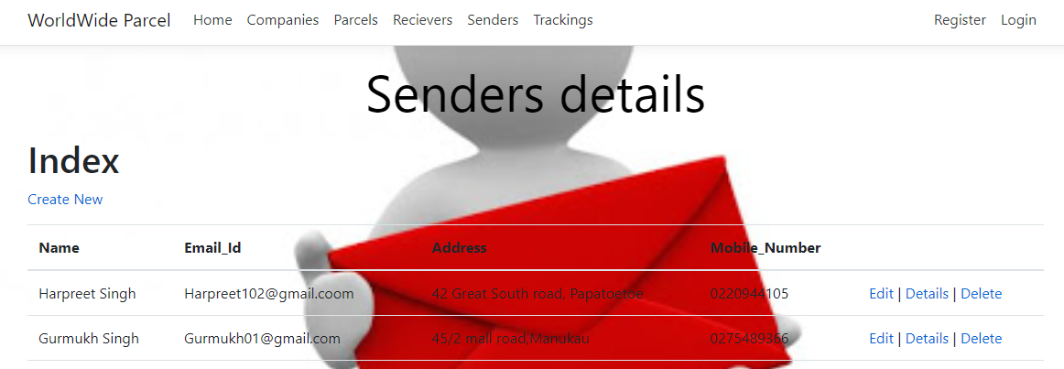

Parcel

Purpose of the Parcel’s page

Through this page customers will be able to get to know regarding the parcel the information belongs to it.

Contents and Elements of Parcel’s page

On this webpage three images are placed to make it effective and under that images there is a large table having foreign key of sender, receiver, and company. Customers can easily check the details parcel including parcel content, shipping cost, company id, receiver id, parcel weight and delivery address and some more.

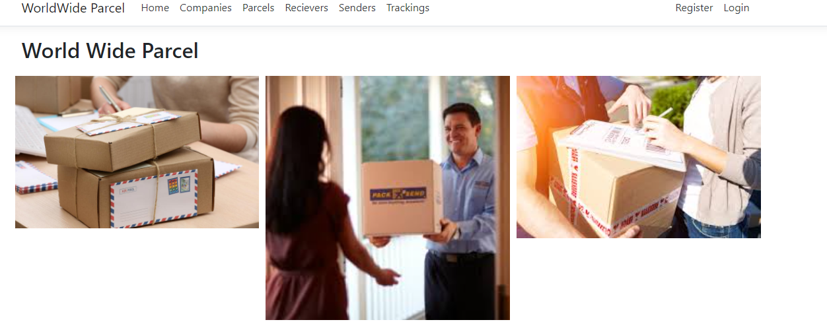

Tracking

Purpose of the Tracking’s page

Through this page customers can easily track their parcel through the given tracking number, which will also enhance customer’s trust.

Contents and Elements of Tracking’s page

On this webpage a background image is placed to make it effective and a large table having foreign key of parcel and the expected date-time.

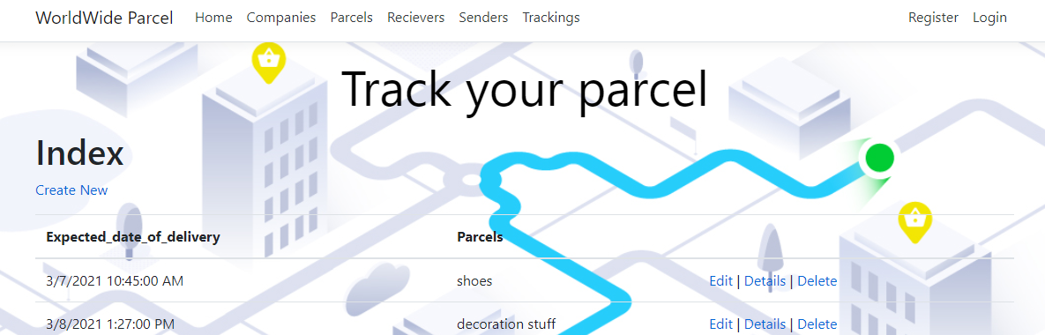

Register page: Register page will help new user to get themselves register so that they can easily access the website means they can add, delete, and edit any changes on the website. and can become member by setting the username and password.

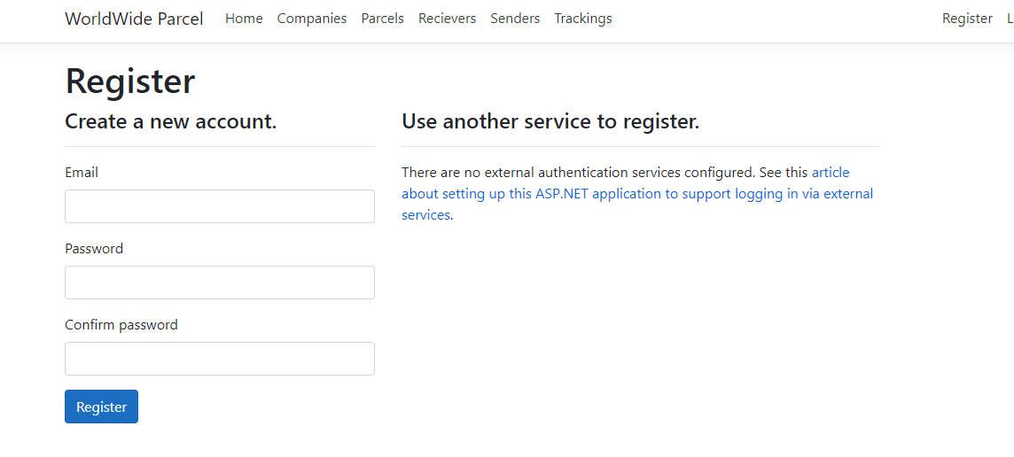

Login page: Login page will allow user to login to use some main function like edit, delete by filling their username and password on the login page.

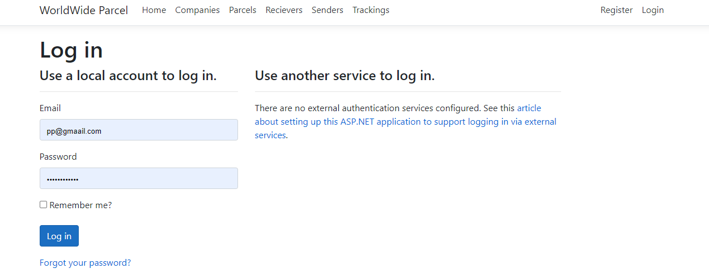

Brand name: Worldwide parcel



Tasks Detail

|  |  |  |
| --- | --- | --- |
| Weeks | Task Description | Duration |
| 1 | Table of content | 250 minutes |
| 2 | Project scope | 70 minutes |
| 3 | Target audience | 200 minutes |
| 4 | Page content details | 300 minutes |
| 5 | brand name | 80 minutes |
| 6 | Task details | 195 minutes |
| 7 | Navigation bar | 75 minutes |
| 8 | Images | 260 minutes |
| 9 | Authentication | 175 minutes |
| 10 | Grammar | 300 minutes |
| 11 | coding | 450 minutes |
| 12 | Final design | 60 minutes |
| **13** | Testing | **330 minutes** |
|  | Total time in hours | 2745\60=53 |
|  | Per hour pay | 45per hour  45x53= $2383nz |

**Navigation bar:** Navigation bar has five pages like companies, receivers, sender, tracking number and parcel and right-hand side it has register and login page.



**Authentication:** The code “Authorize” is used mostly in edit and delete section of every page, so that users who are not registers do any changes for security purposes.